將http用url redirect導到https，再設定 HSTS 標頭即可

<?xml version="1.0" encoding="UTF-8"?>

<configuration>

<system.webServer>

<rewrite>

<rules>

<!--http轉https-->

<rule name="HTTP to HTTPS redirect" stopProcessing="true">

<match url="(.*)" />

<conditions>

<add input="{HTTPS}" pattern="off" ignoreCase="true" />

</conditions>

<action type="Redirect" url="https://{HTTP_HOST}{PATH_INFO}" redirectType="Permanent" />

</rule>

</rules>

<!--outboundRules這一段是跟customHeaders的設定一樣，如果customHeaders有加，這一段就不用加-->

<outboundRules>

<rule name="Add Strict-Transport-Security when HTTPS" enabled="true">

<match serverVariable="RESPONSE_Strict_Transport_Security" pattern=".*" />

<conditions>

<add input="{HTTPS}" pattern="on" ignoreCase="true" />

</conditions>

<action type="Rewrite" value="max-age=31536000" />

</rule>

</outboundRules>

</rewrite>

</system.webServer>

</configuration>

<system.webServer>

<httpProtocol>

<customHeaders>

<add name="Strict-Transport-Security" value="max-age=31536000; includeSubDomains; preload" />

</customHeaders>

</httpProtocol>

</system.webServer>

確認標頭有加入，按F12查看

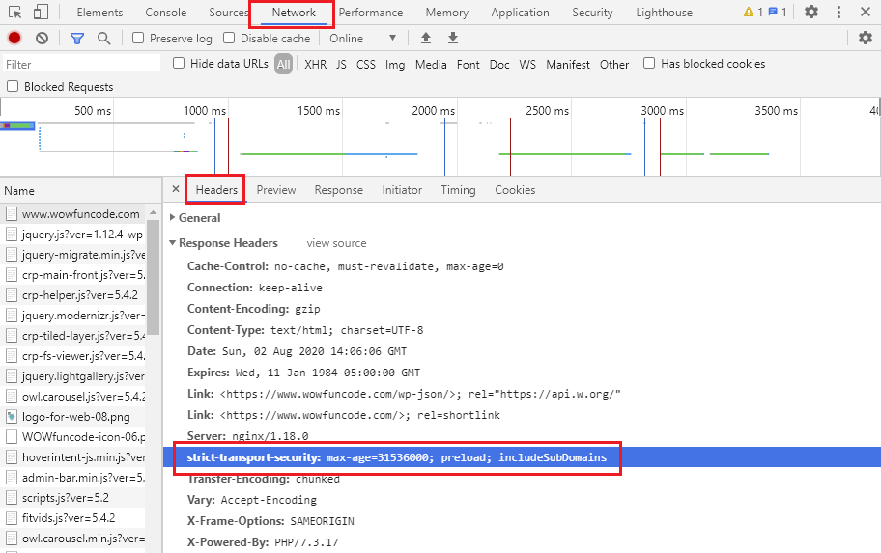

參考

<https://shunnien.github.io/2018/05/08/HSTS-Security/>

<https://iter01.com/562807.html>